# Figures

Figure 1a

Preprocessing

Compute Overlap between populations

MCL Clustering of Populations

Find Best Marker Pair

Repeat until no further separation

Visualize Results

Figure 2

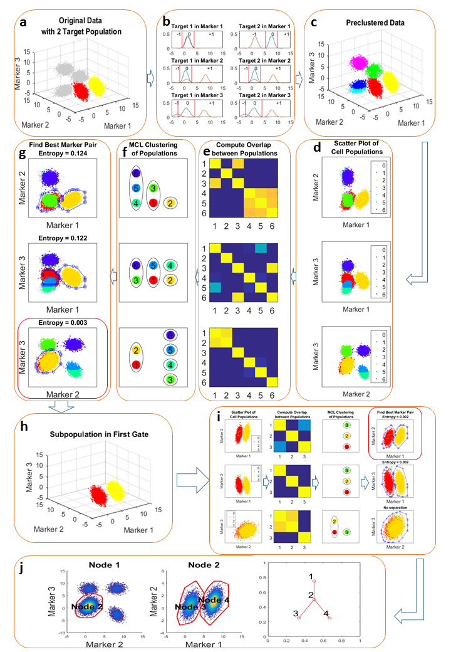

Figure 3a



Figure 3b



Figure 4a



Figure 4b



Figure 5a



Figure 5b



Figure 5c



Figure 6 Know one vs. Know some vs. Know all



Figure 7 Addressing over-clustering



Figure 8 Performance on Different Noisy Level



# Tables

Table 1 Result on manual gated populations

|  |  |  |  |  |  |
| --- | --- | --- | --- | --- | --- |
| Cell Population | In Gate | True Positive | False Positive | False Negative | F-score |
| CD4+ Effmen | 7 | 216 | 13 | 8 | 0.954 |
| CD4+ naïve | 8 | 2267 | 30 | 78 | 0.977 |
| CD8+ naïve | 9 | 488 | 46 | 37 | 0.922 |

Table 2 Result on SPADE defined populations

|  |  |  |  |  |  |
| --- | --- | --- | --- | --- | --- |
| Target Population | In Gate | True Positive | False Positive | False Negative | F-score |
| 1 | 8 | 75 | 9 | 14 | 0.867 |
| 2 | 6 | 3556 | 98 | 0 | 0.986 |
| 3 | 5 | 1569 | 10 | 60 | 0.978 |
| 4 | 3 | 4318 | 0 | 172 | 0.98047 |